**Class Test-2**

1. What is Poisson’s ratio? Derive the relationship between Young’s Modulus and Bulk modulus of an elastic material.

Refer Notes.

1. A square bar 50 mm x 50 mm is subjected to a compressive load of 500 KN. The contraction over 200 mm length is 0.5 mm and increase in thickness is 0.04 mm. Calculate the value of the four elastic constants of the material.
2. Find out the support reactions at the fixed end B of cantilever beam

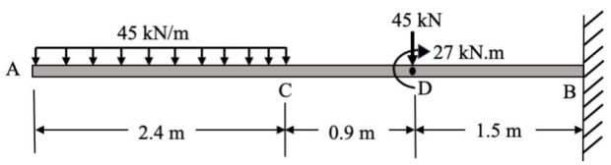

**OR**

A brass bar having cross sectional area of 1000 mm2 is subjected to axial forces as shown in the figure. Find the total elongation of the bar and stress in individual components. Take Modulus of elasticity of Brass = 100 GPa

A beam Det4. Find the reactions at the support points A and B.

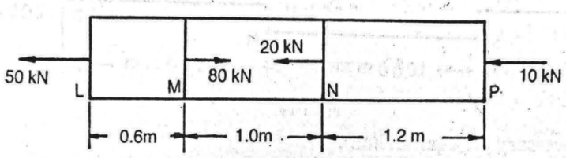

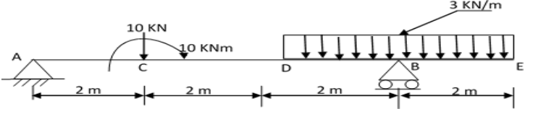

A member ABCD is subjected to point loads P1, P2, P3 and P4 as shown in figure given below. Calculate the force P3 necessary for equilibrium if P1 = 120 kN, P2=220 kN and P4=160 kN. Determine change in length of the member. Take modulus of elasticity 200 GN/m2. Find total elongation.

**OR**

